1. Starting with an empty heap, show the following.

1. The state of the heap after adding in the values: 20, 16, 17, 6, 10, 18, 11, 8, 3
2. The state of the heap after two Dequeue() operations
3. The final, array-based version of the heap

2. Perform a "build heap" operation on the following array:

|  |  |  |  |  |  |  |  |  |  |
| --- | --- | --- | --- | --- | --- | --- | --- | --- | --- |
| 3 | 8 | 9 | 1 | 7 | 7 | 10 | 2 | 1 | 5 |

3. Starting with the supplied binomial heap, add the values 10, 9, 7, 3, and 6. Draw the result.

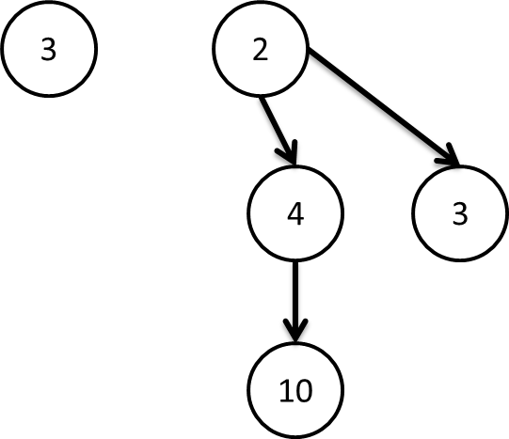

4. Perform 3 dequeue operations on the following binomial heap:

